Section I: Scenario Demographics

Scenario Title: | Stable VT with ICD Firing
Date of Development: | 23/06/2015 (DD/MM/YYYY)
Target Learning Group: | Juniors (PGY 1 – 2) Seniors (PGY ≥ 3) All Groups

Section II: Scenario Developers

Scenario Developer(s): | Kyla Caners
Affiliations/Institution(s): | McMaster University
Contact E-mail (optional): | kcaners@gmail.com

Section III: Curriculum Integration

Learning Goals & Objectives
Educational Goal: | Expose learners to a rare presentation that may trigger discomfort among healthcare workers.
CRM Objectives: | Communicate effectively with team members and reassure them regarding their safety when ICD fires.
Medical Objectives: | - Appropriately call for magnet application in order to terminate ICD firing.  - Perform appropriate initial workup for misfiring ICD.  - Administer appropriate antiarrhythmic therapy for stable VT.  - Administer second line antiarrhythmic therapy for stable VT and seek expert consultation.

Case Summary: Brief Summary of Case Progression and Major Events
A 40-year-old male presents to the ED complaining that his ICD keeps firing. He will have a HR of 180 and VT on the monitor. He will occasionally yell “ow.” The team will need to work through medical management of VT, while considering magnet placement for patient comfort. The patient will remain stable but will trigger VT with his agitation.

Facilitators Required to Run Session
Instructors (faculty or senior resident): 1-2 (one to observe, one to run mannequin if no sim tech)
Confederate nurse: 1 (to assist at bedside, question team re: safety of touching patient)
Sim tech: 1

Section IV: Scenario Script

A. Scenario Cast & Realism
Patient: | Computerized Mannequin |  |  |  |  | Realism:  Select most important dimension(s) |  |  | Conceptual
 | Mannequin |  |  |  |  |  |  |  | Physical
 | Standardized Patient |  |  |  |  |  |  |  | Emotional/Experiential
 | Hybrid |  |  |  |  |  |  |  | Other:
 | Task Trainer |  |  |  |  |  |  |  | N/A
Confederates | Brief Description of Role
Nurse | Question team leader as to safety of touching patient with ICD firing. Cue team to patient’s status PRN (including agitation)
B. Required Monitors
EKG Leads/Wires |  |  | Temperature Probe |  |  |  | Central Venous Line
NIBP Cuff |  |  | Defibrillator Pads |  |  |  | Capnography
Pulse Oximeter |  |  | Arterial Line |  |  |  | Other:
C. Required Equipment
Gloves |  |  | Nasal Prongs |  |  |  | Scalpel
Stethoscope |  |  | Venturi Mask |  |  |  | Tube Thoracostomy Kit
Defibrillator |  |  | Non-Rebreather Mask |  |  |  | Cricothyroidotomy Kit
IV Bags/Lines |  |  | Bag Valve Mask |  |  |  | Thoracotomy Kit
IV Push Medications |  |  | Laryngoscope |  |  |  | Central Line Kit
PO Tabs |  |  | Video Assisted Laryngoscope |  |  |  | Arterial Line Kit
Blood Products |  |  | ET Tubes |  |  |  | Other:
Intraosseous Set-up |  |  | LMA |  |  |  | Other:
D. Moulage
None required. (Can place something under mannequin skin on chest to resemble implanted ICD.)

E. Approximate Timing
Set-Up: |  | 3 min |  | Scenario: | 12 min |  |  | Debriefing: |  | 15 min

Section V: Patient Data and Baseline State

A. Clinical Vignette: To Read Aloud at Beginning of Case
A 40-year-old male to presents to your tertiary care ED complaining that his ICD keeps firing. He keeps yelling “ow” and jumping/jerking every couple minutes during his triage. He has an ICD in place because he had previous myocarditis that left him with a poor EF.
B. Patient Profile and History
Patient Name: Gerald Jones |  |  |  |  |  | Age: 40 |  |  |  |  |  |  |  | Weight: 70 kg
Gender: M F |  |  |  |  |  | Code Status: Full
Chief Complaint: ICD keeps firing
History of Presenting Illness: For the last 20 minutes, ICD keeps firing. Patient is getting very frustrated with how uncomfortable the shocks are.
Past Medical History: |  | Recurrent VT |  |  |  |  | Medications: |  |  |  |  | Amiodarone 400mg daily
 |  | ICD placed 3 years ago for medication-refractory VT
Allergies: None.
Social History: Non-smoker. Denies recreational drugs.
Family History: N/A.
Review of Systems: |  | CNS: |  |  | Nil.
 |  | HEENT: |  |  | Nil.
 |  | CVS: |  |  | Hurts when ICD fires. No preceding CP. No palpitations.
 |  | RESP: |  |  | No preceding SOB or SOBOE.
 |  | GI: |  |  | Nil.
 |  | GU: |  |  | Nil.
 |  | MSK: |  |  | Nil. |  |  |  |  |  |  |  | INT:
C. Baseline Simulator State and Physical Exam
No Monitor Display |  |  |  | Monitor On, no data displayed |  |  |  |  |  |  | Monitor on Standard Display
HR: 180/min |  |  | BP: 100/60 |  |  |  |  | RR: 16/min |  |  |  |  |  |  | O₂SAT: 96% RA
Rhythm: VT |  |  | T: 36.5ºC |  |  |  |  | Glucose: 7.1 mmol/L |  |  |  |  |  |  | GCS: 15 (E 4 V5 M6)
General Status: Alert. Appears very uncomfortable when ICD goes off. Screams very loudly.
CNS: | Alert, oriented. Agitated and begging team to make ICD stop firing.
HEENT: | Nil.
CVS: | No murmur. Pulse palpable at 180. No signs CHF on exam.
RESP: | GAEB. No adventitious. No signs CHF.
ABDO: | Soft, NT.
GU: | Nil.
MSK: | Normal. |  |  |  |  |  |  |  | SKIN: | Palpable ICD to left upper chest.

Scenario States, Modifiers and Triggers
Patient State | Patient Status | Learner Actions, Modifiers & Triggers to Move to Next State
1. Baseline State  Rhythm:  HR: 180/min  BP: 100/60  RR: 16/min  O₂SAT: 96% RA  T: 36.5ºC | Alert and oriented. Stable but very agitated about ICD shocks. Begging MD to make it stop. | Learner Actions  - Apply monitors, full vitals  - Obtain IV access  - Apply defibrillator pads  - Full hx/px  - ECG  - Labs (including extended electrolytes, troponin)  - Apply magnet  - Amiodarone 150mg iv (or lidocaine 1.5mg/kg iv) | Modifiers  Changes to patient condition based on learner action  - Magnet applied Patient stops screaming  - RN asks if safe to touch patient If not reassured, RN will not touch patient  - If plans for sedation/external defib, patient to say “can’t you just unhook this thing instead?”  Triggers  For progression to next state  - 5 minutes 2. Persistent VT
2. Persistent VT  Unchanged. | Patient more calm (if magnet applied). If not, patient unchanged. | Learner Actions  - Second dose amiodarone  - Call arrhythmia/cardiology (will suggest giving procainamide if not yet given)  - Procainamide 20-50mg/min until rhythm stops  - Magnesium sulfate 2g iv | Triggers  - 2 min after procainamide given 3. VT resolution  - 8 minutes 4. Patient agitated
3. VT resolution  Rhythm Sinus  HR 95  BP 110/70 |  | Learner Actions  - Call arrhythmia  - Consider procainamide infusion  - CXR re: lead placement | Triggers  - 1 min into state 4. Patient agitated
4. Patient agitated  Rhythm: VT  HR: 180/min  BP: 150/90 | Patient gets very upset about needing to be in hospital and triggers VT. | Learner Actions  - Consider benzodiazepine administration  - Provide reassurance  - Restart procainamide (if stopped)  - Magnesium sulfate 2g iv (if not yet given)  - 3rd dose amiodarone  - Consider esmolol 500mcg/kg bolus then 50mcg/kg/min infusion | Modifiers  - Reassurance of patient by dedicated team member Patient calms down  Triggers  - Benzo given 5. Resolution  - 12 minutes 5. Resolution
5. Resolution  Rhythm Sinus  HR 95  BP 110/70 | Patient calm. | Learner Actions  - Call arrhythmia  - Amiodarone infusion or procainamide infusion | END CASE 1 minute into state Arrhythmia arrives
Section VI: Scenario Progression

Section VII: Supporting Documents, Laboratory Results, & Multimedia

Laboratory Results
None required for case.

Images (ECGs, CXRs, etc.)
ECG – VT
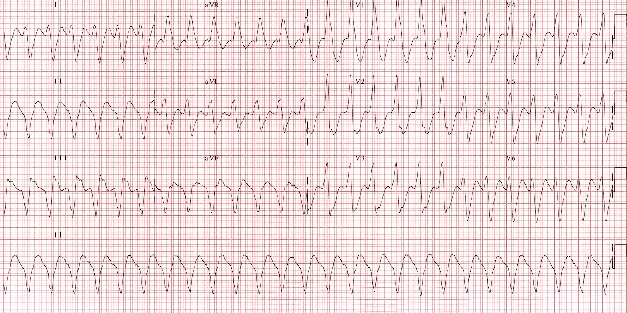
ECG source: http://lifeinthefastlane.com/ecg-library/ventricular-tachycardia/
CXR – ICD in good position
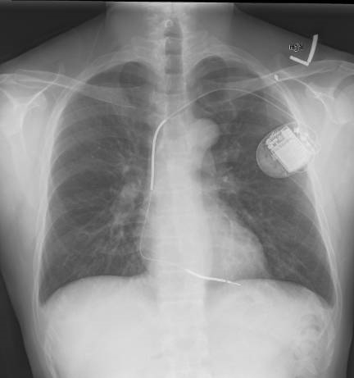

CXR source: https://commons.wikimedia.org/wiki/File:Implantable_
cardioverter_defibrillator_chest_X-ray.jpg
Section VIII: Debriefing Guide

General Debriefing Plan
Individual | Group |  | With Video | Without Video
Objectives
Educational Goal: |  | Expose learners to a rare presentation that triggers discomfort among healthcare workers.
CRM Objectives: |  | Communicate effectively with team members and reassure team members regarding their safety when ICD fires.
Medical Objectives: |  | - Appropriately call for magnet application in order to terminate ICD firing.  - Perform appropriate initial workup for misfiring ICD.  - Administer appropriate antiarrhythmic therapy for stable VT.  - Administer second line antiarrhythmic therapy for stable VT and seek expert consultation.
Sample Questions for Debriefing
- How did it feel to have your colleague questioning your judgment around the safety of touching the patient? Do you have any strategies for dealing with conflict among coworkers?
- What is your approach to the management of stable VT? What antidysrhythmic options are there?
- What effect does placing a magnet have for an ICD? For a pacemaker?
- Does ACLS management change in a patient with an ICD?
Key Moments
Acknowledging safety of touching patient.
Working through antidysrhythmic treatment options.
Management of catecholamine surge.

